The complex and conflicting reality that educational leaders face

Yi Chen

Teachers College, Columbia University

Refection Three for Research, Theory, and Practice in Education Leadership

Abstract

*Abstract*: The goal of this reflection paper is to summarize the complex and conflicting reality that an educational leader needs to face. In the application, I will discuss the educational leadership in China and what we can learn from the research and practice in United States.

Keywords: Teaching, Learning, Administration, Text Mining

The complex and conflicting reality that educational leaders face

# Comprehension & Evaluation

This weeks’ reading gives us a more real and comprehensive reality of education leadership. The role of principal is discussed in a broader context inside and beyond school. In the previous weeks, we focus more on the internal managerial and administrative role of leader inside the school environment. However, the challenge of educational leadership is much more than that. Firstone and Shipps (2005) summarized five types of leaders’ accountabilities (political, bureaucratic, market, professional, and moral). In reflection two, I mentioned Figure one, which indicates the central position of school leaders in the whole framework of student learning. Even though leaders do not have direct effect on students in most time. However, they are providing the environment that makes the improvement of student learning possible. Among all of these environments, we emphasis the school conditions (e.g., culture and community). School Leaders are encouraged to bridge the connection between school and community more actively. Meanwhile, parents and other community members should have the access to directly engaging into the teaching and learning process collaboratively. This is a distributed leadership philosophy. Even the power is transferred to teachers, parents, and other out-of-school contexts, the challenges of leadership seems only to more arduous.

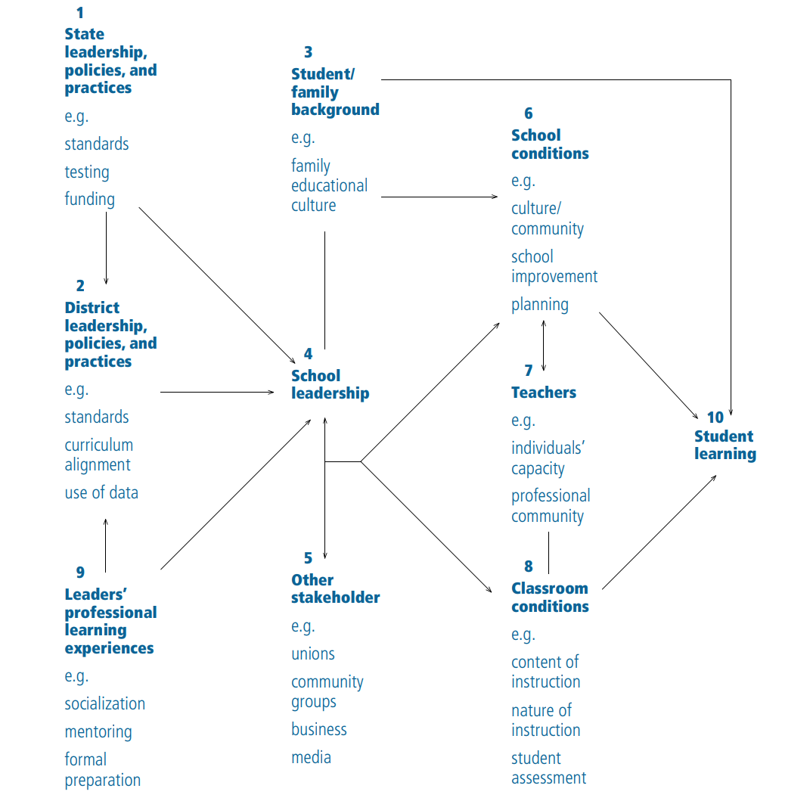

Figure 1. Linking Leadership to Learning (Kenneth et al. ,2004))

From my perspective, every types of accountability are critical. However, it seems to be too overwhelming for a single position (principal). Every accountability even ends up with more challenging and unsolved problem in practice. For example, how to lead the development of community and social capital for student learning? We cannot guarantee the parents and other community members have the professional skills and adequate information to practice fully in school governance. How can we keep the balance of engagement of out-of-school contexts and the professionalism of education? (Dirscoll and Goldring, 2005)

This may explain why many turnover projects end up with disaster. The very notion of systemic, sustained improvement ran counter to the usual cycle of adoption-and-abandonment. (Peurach & Marx,2010). How can a leader quickly take steps to the changes inside and outside school? How can the leader win the trust from the community members and encourage the out-of-school contexts to improve? In big and complex company, there will have CEO, CTO, COO, and CFO. These people take the responsibilities of leadership, techniques, organization, and finance together. The mutual checks and balance between these positions ensure the company develop sustainably. However, there is only one position for the leader of school.

“Subtraction” maybe better than “addition”. As Dirscoll and Goldring (2005) emphasized “an effective principal was those who on longer buffer but rather bridge with the communities”, school leader should open the “closed system” and allows people outside school to engage in making the decision. Instead of a command-and-control waterfall inside school, leadership should be a collaborative and learning process with more cross-functional participants. This idea is similar to Scrum. However, are these supports good enough?

However, does transformational leadership and distributed leadership always work better than instructional leadership? As what has been mentioned in the class, the only few examples that school leadership can be successful with strong evidence is through clear target and efficient management. I believe there should have some priorities among all of these accountabilities under different condition. But I did not get a clear answer. And, how can the leader quickly adjust their leadership strategy before it becomes too late?

# Application

In this section, I want to discuss the school leadership in China based on my personal experience. Using the framework of Firstone and Shipps (2005), principal in China also share the internal and external accountabilities.

In terms of political accountabilities, Chinese principal follows a strong control by the provincial and central government. Principals have very limited autonomy in curriculum design. The pressure from local citizens are also limited for two reasons:

* Strict residency and household registration system restrict the free choice of school across different region. Sending the students to the assigned school (mostly based on household) is required by law. Additionally, public school is usually the best choice, in particular for high school. Few competitive private schools are too expensive for the middle class. Thus, the option is limited for local citizens;
* Teachers have relatively closer relationship with parents than principals. In most school, there is a header teacher for each class who control the overall performance. Then, a grade and subject leader will focus on the performance of single grade and single subject. The leadership is distributed in a hierarchical structure. Usually principal do not need to face the pressure directly from individual parent.

Chinese principal focus more on the bureaucratic accountabilities. With a clear target (e.g., better performance of standardized testing), leaders in school is more managerial. Usually, teachers and students are required to follow strict rules. Meanwhile, the market competition for traditional school is limited. However, the K12 and STEM-related after-class training is developing quickly.

This practice for a long term indeed ensures the improvement of learning for the student in general. In particular, Chinese students usually accumulate profound knowledge and skills in the STEM subjects. However, this also course the problem of justice and all-round development for every individual student. Currently, most family rely on the after-class training (in particular during summer and winter holiday) to fulfill the field that is not fully considered by the school education. For example, art, music, and sports. However, students also complain there are too much load. Thus, it will be too overwhelming for them to keep the habits of something irrelevant to standardized testing.

The whole society rely more on the revolution of standardized testing and requirement from universities. The leaders in the department of educational administration at city or province level usually plays the most important role. For example, recently Zhejiang Province (my hometown) allows the student to freely choose three out of seven subjects (physics, chemistry, biology, history, philosophy, technology and geography) that they want to take for the college entrance exam. The subjects that they choose will influence the major they can apply after high school. This requires students to think about their career path earlier based on their own interests and talent. For example, if I want to major in geographic information technology in the future, I can focus my study on geography, technology, and physics during the high school.

Once a clear target is set, school leaders and teachers will quickly adjust to it and aiming at getting a higher score for each student. In terms of communities’ role in student learning, usually it is disconnected with school. There is very limited resource and services consistently and directly aiming at the students in communities as well. In most case, families take the whole responsibility of education beyond the school. This is based on the close and cohesive Chinese family culture. When parents are busy with their work, they will encourage the grandparents to take care of the children. Because it is economic and safe.

Fundamentally, this policy setting aggravates the inequality in education. Rich family have the access to better public school and can afford expensive after-class training. Even though, the curriculum designed by the central government is comprehensive. However, the one-fits-all measurement system makes usually emphasis on very limited number of subjects. Thus, other subjects will automatically be marginalized.

In the education context of China, we can see the limited role of school leader. The main goal usually is to fulfill the requirement from the department of educational administration through clear and strong management in daily school governance. The improvement of the education practice rely more on the whole social context instead of just school leaders.

References

Dimmock, C. (1995). Principals and School Restructuring: Conceptualizing Challenges and Dilemmas. Journal of Educational Administration, 441-462.

Leithwood, K., Seashore K., Anderson S., & Wahlstrom K., Center for Applied Research and Educational Improvement Report (2004). *How Leadership Influences Student Learning*, Retrieved from <https://www.wallacefoundation.org/knowledge-center/Documents/How-Leadership-Influences-Student-Learning.pdf>

Susan M. J., (2004) *Helping Teachers Learn: Principal Leadership for Adult Growth and Development*, Oaks, California: Corwin Press

Driscoll, M.E., Goldring, E.B. How can school leaders incorporate communities as contexts for student learning? P.61-80

Firestion, W.A., Shipps, D. How do leaders interpret conflicting accountabilities to improve student learning? P. 81-100

Stogdill, R. R. (1948). Personal Factors associated with leadership: A survey of the literature. *The Journal of psychology*, 25: 35-71

Mann, R. D. (1959). A Review of the Leadership between Personality and Performance in Samll Group, *Psychological Bulletin*. 56

Zaccaro, S. J., Kemp, C., & Bader, P. (2004). *Leader traits and attributes*. In Antonakis, J., Cianciolo, A. T., & Sternberg, R. J. (eds.), *The Nature of Leadership*, Sage, Thousand Oaks, CA, pp. 101-124.

Bales, R. F. (1951). *Interaction process analysis: A method for the study of small groups*. Addison-Wesley, Reading, MA.